Spine symbols requirements:
Export spine 4.0
Folder: should be relative to resources folder ../../../resources/assets/spine
Format: JSON
Example:
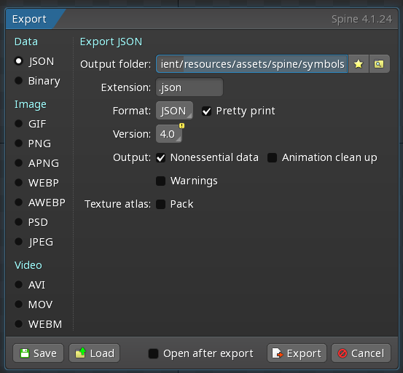
All images should be from root of ‘origin.resources’
Static symbols art is located in a spine file and should be attached to relative skin.
Skins also includes subfolder for blur symbols, it would be good to save the same name for each symbol.
Static art should be in
Static art should be in one layer folder, it should not be in multy sub-layer folders.
For example, if you need one folder for a symbol you need to put it in .\resources\origin.assets\atlases\high1 folder and then you would be able to use art from this folder in symbols.spine
If you want to make more that 1 folder for one symbols you need to do this on atlases level folder.
For example, it could be .\resources\origin.assets\atlases\high1_slices and .\resources\origin.assets\atlases\high1_sequence
You also can put everything in one folder, but we have limitation on one art, currently we cannot use multi atlases(for sure, one folder – one future atlas)
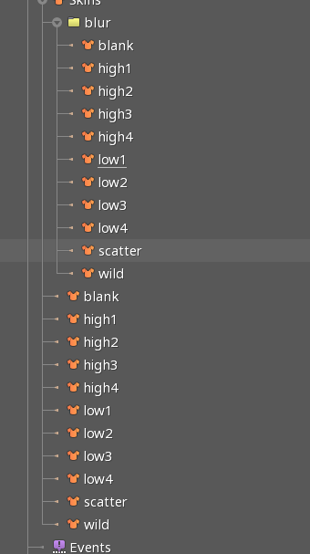

Animations attached to symbols and could be different for each symbol.
Required animations:
- Idle
- Land
- Dim
- Dim_for_spin
- Undim
- Undim_for_spin
- Win
For more complex animations we would need a call to get our vision of how we could do this.
If we already have someone of animation it would be good to get it firstly as soon as possible to analyze it and provide complex vision of what we need to adjust to get it works.
Update at 12/6/2023
Skinnable placeholders should not be empty between skins, this could leave artifact in our game client after changing one skin on another one.
Feedback from first draft:
Draft animations look awesome.
First what I found is a images path. We should fix it on root of “origin.assets”. For example, on my machine it look like this: C:\dev\scgp\game-client\resources\origin.assets.
Second: is a for different win animations we have mid_1_win and mid_2_win. We should have one win animation for all skins.
Third: Awesome pictogram is to complex. I get performance drop to 40fps on middle devices, we should avoid too complex animations.
Also I found that in this assets pack we have bigger symbol size than we have in static art. I set 0.65 scale for “symbol_sizer” bone. Now it around expected size.
It would be good to have all skins and animations in next animations draft. It take some time to merge all in one when we have only small part and want to check it in game. Pls follow or use example from zip.
Small plus to all requirements, I have added them at top. Spine skin placeholder should not be empty when between other skins. Our platform ignore empty skins and whem we changing symbol skin on next one, we could get artifact from previous one.

